Task 9 Output

LS1_resnet_5_kmeans, k=10, label = 0
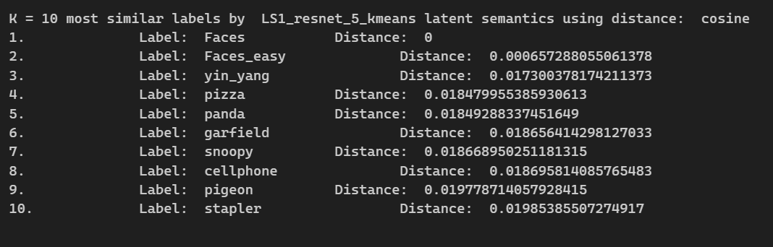

LS1_resnet_5_kmeans, k=10, label = 20

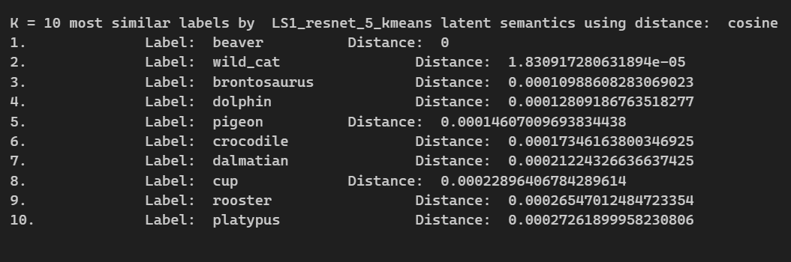

LS1_resnet_5_kmeans, k=10, label = 100

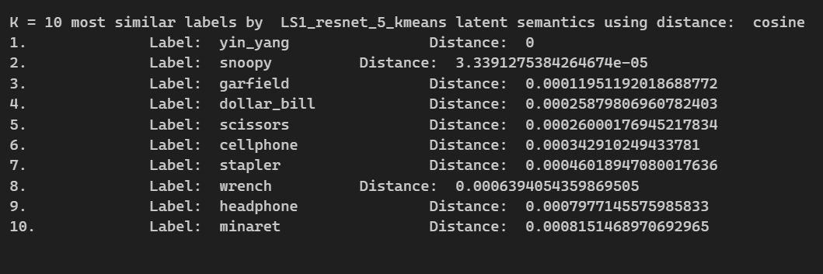

LS3_resnet_5_kmeans, k=10, label = 0

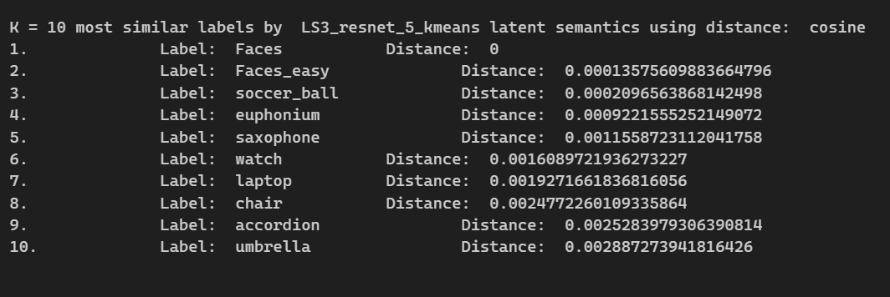

LS3_resnet_5_kmeans, k=10, label = 20

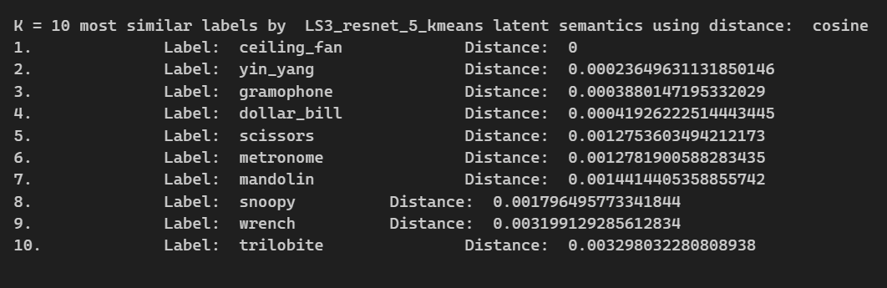

LS3_resnet_5_kmeans, k=10, label = 100

